For every action there is an equal and opposite reaction — Newton's Third Law
Reciprocity & Exposure Equivalence
Reciprocal exposures are the same

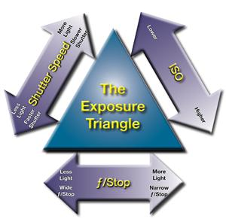
Use The Exposure Triangle to keep the exposure the same
- ISO
- Shutter Speed
- ƒ/Stop

Together these make up the exposure value (EV) for a given setting.

Change one of these and you will need to change at least one of the others or both to keep the exposure the same.

Links

http://www.exposureguide.com/exposure.htm

http://www.cambridgeincolour.com/tutorials/camera-exposure.htm

http://digital-photography-school.com/learning-exposure-in-digital-photography

Exposure Charts
Downloadable chart to use when working problems
Exposure Calulation Work Charts

Use the following chart to aid in finding the correct reciprocity (equivalent or same) exposure
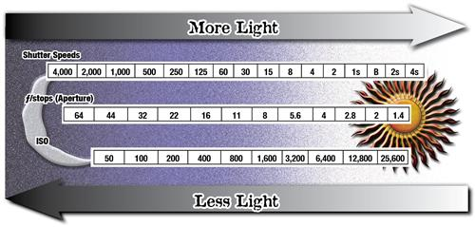

Exposure Chart with Explanation
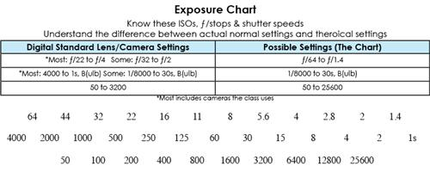

Steps in determining exposure calculations
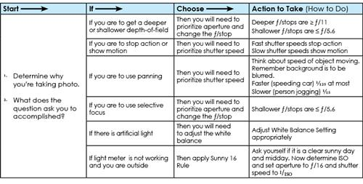

Example Problems
General adjustments with example settings

Initial  Light Meter  Reading | Adjust to  Stop Action | Adjust to  Show Movement | Adjust to Increase  Depth-of-Field  (Deep) | Adjust to Decrease  Depth-of-Field  (Shallow)
ISO  400 | Only increase if not enough light to increase SS | Only decrease if too much light to decrease SS enough | Only increase if not enough light to increase ƒ/stop | Only decrease if too much light to decrease ƒ/stop
SS  1/250 | Raise Shutter Speed  (faster time)  by subtracting light  – 3 stops  SS 1/2,000 | Lower Shutter Speed  (slower time)  by adding light  + 3 stops  SS 1/30 | Adjust SS back to to ±0  by decreasing SS  adding light  + 3 stops  SS 1/30 | Adjust SS back to to ±0  by increasing SS  subtracting light  – 3 stops  SS 1/2,000
ƒ/8 | Adjust ƒ/stop back to to ±0  adding light  + 3 stops  ƒ/2.8 | Adjust ƒ/stop back to to ±  subtracting light  – 3 stops  ƒ/22  0 | Increase ƒ/stop  (make aperture small)  subtracting light  – 3 stops  ƒ/22 | Decrease ƒ/stop  (make aperture large)  adding light  + 3 stops  ƒ/2.8

Story Problems
1. Meter Reading ISO 400 1/500 @ ƒ/5.6
You're photographing a baseball game and you want to stop the movement of the baseball and bat.
Best shutter speed is a fast one like 1/1,000 what is the new ƒ/stop?
Using the chart (or your memory) find the difference in stops from 1/500 and 1/1,000, it's –1 stop.
Calculate new ƒ/stop, ƒ/5.6 +1 stops new stop would be ƒ/4
New reciprocal exposure is ISO 400 1/1,000 @ ƒ/4

2. Meter Reading ISO 800 1/60 @ ƒ/4
You're photographing a landscape and you want to show your friend in the foreground, the trees behind them and the mountain behind all in focus. You want a deep depth-of-field.
Best ƒ/stop is a high one like ƒ/16 what is the new shutter speed?
Using the chart (or your memory) find the difference in stops from ƒ/4 to ƒ/16, it's –4 stop.
Calculate new shutter speed, 1/60 +4 stops (let in more light) new shutter speed would be 1/4
New reciprocal exposure is ISO 400 1/4 @ ƒ/16
But there is a problem
Shutter speed to slow to capture your friend standing there. So you need to change the ISO higher so the shutter speed will stop your friend standing.
New ISO 400 +4 stops = ISO 6400
New reciprocal exposure is ISO 6400 1/60 @ ƒ/16

